
2026
SUNDAY | MONDAY | TUESDAY  September | WEDNESDAY | THURSDAY | FRIDAY | SATURDAY
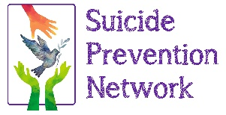  For more information contact: Kristy Vann  kristy@spnawareness.org or 530-721-1408 |  | 1 | 2 | 3 | 4 | 5
 |  |  | Swim/Yoga Passes at the Hung A Lel Ti Fire House 10a-11p |  | Swim/Yoga Passes at the Markleeville Library 11a-12p | Suicide Prevention Networks: Wellness Fair and You Matter Walk 10:30a-2:30p
6 | 7 | 8 | 9 | 10 | 11 | 12
 | Labor Day |  | Swim/Yoga Passes at the Hung A Lel Ti Fire House 10a-11p  Family Movie Night 5:30p-7:30p | Elder’s Morning Movie 10a-12p  Safe TALK Training at Partnership 1p-4:30p | Create the Good at the Hung A Lel It Fire House 12p-2p | Caples Lake Kids Fishing Day at Caples Lake Resort 11a-3p
13 | 14 | 15 | 16 | 17 | 18 | 19
Alpine Kids Ace’s Game at 12:30p |  |  | Kristy Out of Office  Hung A Lel Ti  September Birthday chili contest 6p | Elder’s Outing 11:30a- 1:30p | Swim/Yoga Passes at the Markleeville Library 11a-12p | Markleeville Creek Day at the Markleeville Library 9a- 12:30p
20 | 21 | 22 | 23 | 24 | 25 | 26
 |  |  | Swim/Yoga Passes at the Hung A Lel Ti Fire House 10a-11p  Family Game Night 5:30p- 7:30p | Tribal offices Closed due to Employee Appreciation Day | Native American Day
27 | 28 | 29 | 30 | 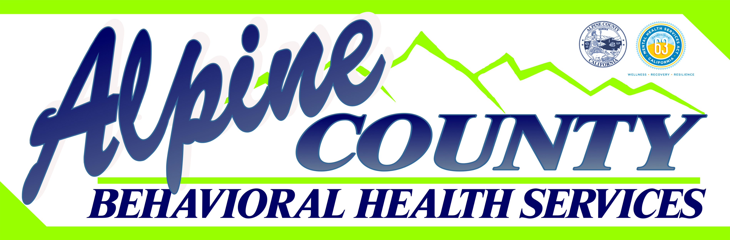
 |  |  | Swim/Yoga Passes at the Hung A Lel Ti Fire House 10a-11p

